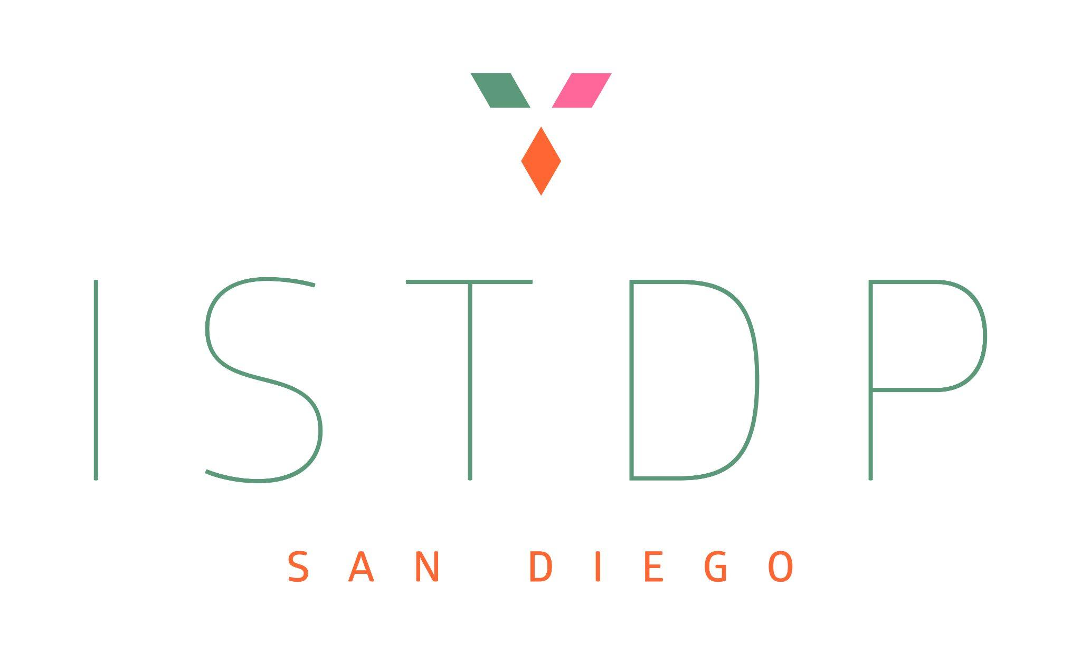
ISTDP San Diego Core Training Program
www.istdpsandiego.com
www.facebook.com/groups/619623708442862
istdpsandiego.eventbrite.com
istdpsandiego@gmail.com
IEDTA Certified Teachers: Tami Chelew & Matthew Jarvinen

Registration & Training Agreement

Name:
Address:
City:
Post/Zip Code:
Country:
Phone:
Email:
Degree:
Licensing organization:
License number:

3-Year Core Training in ISTDP – Integrating Theory, Application & Person of the Therapist:

A Transformational Training for Therapists Committed to:
In-Depth Learning, Growing in Self Mastery, and Conscious Integrative Practice
with Certified IEDTA Teachers Tami Chelew, LMFT and Dr. Matt Jarvinen, PhD
The Format: Four 3-day modules per year, over 3 years
- Didactic teaching, clinical video, PowerPoints, required readings, and theory integration
- Application: Group supervision using your own session videos and watching clinical video
- Practice: Role plays to enhance clinical thinking, counter-transference, and integration
- Group process time, reflection, and learning integration

Each training block will deepen your understanding in:
- The Metapsychology, Theory, and Practice of ISTDP
- Applying the Central Dynamic Sequence with the Standard Format of ISTDP
- Applying the Graded Format of ISTDP for Capacity Building Efforts as needed
You will learn to see through the lens of ISTDP’s rich metapsychology, developing the capacity to:
- Accurately psychodiagnose by assessing a patient’s capacity
- Understanding the Central Dynamic Sequence
- Apply inquiry, pressure, bracing, recapping, gentle challenge, challenge, and head-on-collision interventions grounded in accurate psychodiagnosis and capacity building
- Form and strengthen the Conscious Therapeutic Alliance
- Recognize the patient’s core conflicts and the ways these are enacted in the transference
- Identify defenses and understand their emotional and relational costs
- Work with defenses as they shift from syntonic to dystonic
- Assess and track unconscious anxiety pathways
- Monitoring unconscious anxiety thresholds when on, near, or over threshold, and how and when to use bracing and recapping interventions to both build capacity and work at the patient’s highest capacities using the graded format
- Recognize transference enactments and how to identify them
- Recognize and skillfully follow the rise of complex transference feelings
- Listening and following the Unconscious Therapeutic Alliance — the innate healing force within each patient — to facilitate breakthroughs into the unconscious
- Support the patient with the working-through process, leading to integration, a more open and fluid consciousness, and lasting change.
In this approach, we honor both the technical foundation of ISTDP and the heart-centered, relational presence needed to awaken the healing force within each person. The training is not only about skill acquisition, but also about developing therapeutic presence, courage, flexibility, sensitivity, attunement, and precision. In doing so, we will help you to invite patients to experience the deepest levels of truth, and to transform their lives through in-depth character change.
Over three years, you will learn to:
- Develop and grow your understanding in ISTDP theory — understanding the neurobiological, psychodynamic, and attachment foundations of intensive short-term dynamic work.
- Apply ISTDP in practice — through microanalysis of your own clinical work, video supervision, and skill-building exercises that deepen your clinical thinking skills
- Person of the Therapist — Build capacity and deeper awareness of learning to track your own feelings, anxiety pathways, and defenses that can hold you back from engaging with your authentic self. We believe your personal evolution becomes as important as your technical skill.
- Integrate both the inner and outer work — developing the emotional capacity, self-awareness, and resilience that allow you to meet patients in the most vulnerable human spaces.
- On the final training block, participants will each provide a presentation of a clinical case. The recorded material will demonstrate capacity to apply EDT fundamental techniques.
Who This Is For:
This training is exclusively for licensed mental health and registered health professionals, including Psychiatrists, Psychologists, Social Workers, MFTs, Counselors, as well as Physicians, Nurses who are committed to:
- Co-creating a safe therapeutic group learning alliance together through mutual respect and compassion for self and other
- Learning how to work with the unconscious
- Personal and professional growth
- Integrating the art and science of therapy
- Working to make unconscious processes conscious
Course Details
This new Core Training program in ISTDP will begin in 2026. Hybrid in-person and online options will be available depending on interest and need. While in core training, trainees will receive 50% discounts off general admission to all ISTDP San Diego Trainings (average 3-5 events per year). The core training will also provide 19.5 CEs per block.
At each training block, trainees are expected to present a tape of their therapy work for consultation. Each trainee will receive individual consultation at each training block.

Dates & Presenters
This core training will be co-led by Tami Chelew and Matthew Jarvinen. The days and times for the four 3-day first-year training blocks will be Thursday-Saturday. Exact dates and times for the blocks will be confirmed once applicants are approved.

Fees & Payment
The annual fee for this 3-year training package is $4700 USD and is due before the beginning of the first block. If needed, you may pay $1175 per block, but this is a year-long commitment, so you are required to pay for all 4 blocks, even if you end up missing a block. Payment by PayPal or international bankers draft should be in $USD and made payable to Tami Chelew Therapy. Service fees may apply. An e-transfer bank to bank can also be arranged. From international bank accounts, an international wire transfer can be made (account details on request).

Training Agreement
The ISTDP San Diego Core Training Program is a 3-year course for health professionals or those in training at an institution of higher education. I understand that I am registering to participate in a 3-year course with a commitment to pay for each year of training in full according to the fee schedule listed above.
This fee is non-refundable once paid. In the event a trainee decides to drop out before completing the year, they are still expected to pay for all blocks. For the duration of my participation in the training program I will retain my professional registration as a healthcare professional or student and agree to inform the trainers of any change in this status. Trainees are expected to follow the ethical standards of practice as outlined by their respective licensing board and/or University, and the ethical standards of the IEDTA. We ask trainees to notify us if an ethical complaint has been made against you. If these ethical standards are violated, participation in the core training may be suspended or terminated without refund.
Trainees agree to keep all clinical information presented during training blocks strictly confidential, and under no circumstances is recording of any of the training content permitted. Trainees may record their individual supervision with permission, purely for their own learning and not to be shared. Trainees are responsible for securely deleting all recordings by the end of the program or before if requested. The course trainers agree to provide a clinical case consultation at each training block for the trainees’ learning purposes. I understand that as the clinician, I am solely responsible for the clinical care I provide to patients.
Core trainees are also expected to comply with the ethical standards of their licensing organization and the ethical standards of the IEDTA. We also ask trainees to notify us if an ethical complaint has been made against them. If these ethical standards are violated, participation in the group may be terminated or suspended.

IEDTA-Certification
We are in the process of applying for this to be accepted as an IEDTA-certified core training. Once accepted, at the end of the 3-year training program, participants who have completed all 12 blocks of case consultation and didactic teaching, will be provided certification of completion of a IEDTA-certified core training program. Consistent with the requirements for IEDTA-certification, each trainee will receive at least 80 hours of teaching (other than supervision) and 15 hours of group or individual supervision of her or his own cases within a 3-year period. If a block is missed, in order to qualify for IEDTA-certification, the trainee would need to pay for a makeup 75-minute supervision time with Tami or Matt at their hourly supervision rate.

IEDTA Membership
Trainees will be eligible for a free IEDTA membership for the entirety of the core training (up to 3 years), with possible additional discounts for the 2-years following the core training. Once enrolled in the core training program, trainees can register for that membership here: https://iedta.net/iedta/membership/.

Continuing Education (CE) Credits
19.5 Continuing Education credits are available for each 3-day block for an additional $50 (plus Eventbrite transaction fees). Failure to log in/out or attend the course in its entirety will result in forfeiture of credit for the entire course. No exceptions will be made. Partial credit is not available. There is no conflict of interest or commercial support for this program.
Once the course is completed and attendance confirmed, an evaluation will be sent to you via email from Karen Newell at newell@sonic.net. Please contact her with any questions about CEs.
CUE Management Solutions, LLC is approved by the American Psychological Association to sponsor continuing education for psychologists. CUE Management Solutions, LLC maintains responsibility for this program and its content.
CUE Management Solutions, LLC is recognized by the New York State Education Department’s State Board for Psychology as an approved provider of continuing education for licensed psychologists #PSY-0242.
Please Note: Licensing Boards change regulations often and while we attempt to stay abreast of their most recent changes, if you have questions or concerns about this course meeting your specific board’s approval, we recommend you contact your board directly to obtain a ruling.
This training is exclusively for licensed mental health and registered health professionals, including Psychiatrists, Psychologists, Social Workers, MFTs, Counselors, as well as Physicians, Nurses, Physical Therapists, etc. If you are not a mental health or health professional, you may not attend due to the protection of patient confidentiality. Students and trainees pursuing licensure or registration as a mental health or health professional under supervision are welcome. The course content level is Intermediate level.
CE Learning Outcomes: Participants will be able to:
1. Identify the ISTDP Metapsychology
2. List the corners of the Triangle of Conflict
3. List the corners of the Triangle of Person
4. Describe Complex Transference Feelings (CTF)
5. Describe the Unconscious Therapeutic Alliance (UTA)
6. Describe the Types and Manifestations of Resistance
7. Describe the Types and Manifestations of Fragility
8. Describe the ISTDP Psychodiagnostic Evaluation
9. Follow the steps of the central dynamic sequence in ISTDP
10. Apply interventions of pressure, identification and challenge of defenses, head-on collision, bracing, and recap.
11. Monitor the 5 parameters in ISTDP: active unconscious anxiety discharge pathways, presence and height of thresholds, active major defense patterns, degree to which resistances are syntonic versus dystonic, rise in complex transference feelings.
12. Describe the Application of ISTDP for Patients across the Spectra of Resistance and Fragility

I understand and agree to these terms and conditions.

Signature: Date:

Please send the completed application to istdpsandiego@gmail.com.

For all new participants, applications should include:
- A copy of your curriculum vitae
- A brief description of your experience practicing psychotherapy, including any prior experience of training in ISTDP.
- A copy of the professional license (or supervisor’s license).
Payment of $4700 per year or $1175 per block paid via PayPal as Friends and Family to tamichelew@gmail.com in $USD to secure your spot.

For those interested in our Core Training, we will set up a brief individual interview in order for all three of us to get a chance to get to know each other.

Thank you and we look forward to supporting you in your learning journey in ISTDP,
Tami and Matt

Tami Chelew, LMFT, has trained in Intensive Short-Term Dynamic Therapy since 2015. She is an IEDTA Certified Teacher, an IEDTA Supervisor Candidate, Past President of the IEDTA, and Dually Certified in AEDP and Certified in EFT Couples Supervisor and Teacher. Tami has been supervising and teaching students since 2012. She has expanded her practice and teaching to applying ISTDP for Couples. Tami offers ISTDP for Couples Consultation groups. She is the Co-founder of ISTDP San Diego Community with Dr. Matt Jarvinen, which was formed in 2019. ISTDP San Diego Community was created to build community and teaching opportunities with other like-minded clinicians to spread the love and efficacy of ISTDP. Tami is invited to present her ISTDP clinical work for individuals and couples, both locally and internationally. Tami has been married for over 35 years, has two grown daughters, and together they have 3 grandchildren that keep their lives full.

Dr. Matthew Jarvinen is a licensed clinical psychologist specializing in Intensive Short-Term Dynamic Psychotherapy (ISTDP). He is an IEDTA-certified teacher, and has completed an IEDTA-certification core training, as well as advanced training and teacher training in ISTDP. He has received supervision from Robert Neborsky, Jon Frederickson, Allan Abbass, Patricia Coughlin, Josette ten Have-de Labije, and Steve Shapiro. He currently serves on the IEDTA Board as the Chair of Membership and Community Committee. He also founded the ISTDP San Diego Community with Tami Chelew, which hosts regular online trainings in ISTDP (30+ to date). He also runs an ISTDP-focused group practice (EmotionFit) where he supervises and trains four therapists in ISTDP. He currently works full-time in private practice and lives in Encinitas, CA with his wife and two children.

